Steps to identify the code coverage using Emma Ant Commands

## Step 1: Install the Ant

Install ant from the link <http://ant.apache.org/srcdownload.cgi> and set their path in the environment variables ( My Computer ->Properties ->Advanced ->environment variables)

Set the system variable path with the ant path and try ant command in the cmd prompt.

If you were able to get the below screen,it shows that ant is configured properly in your system.

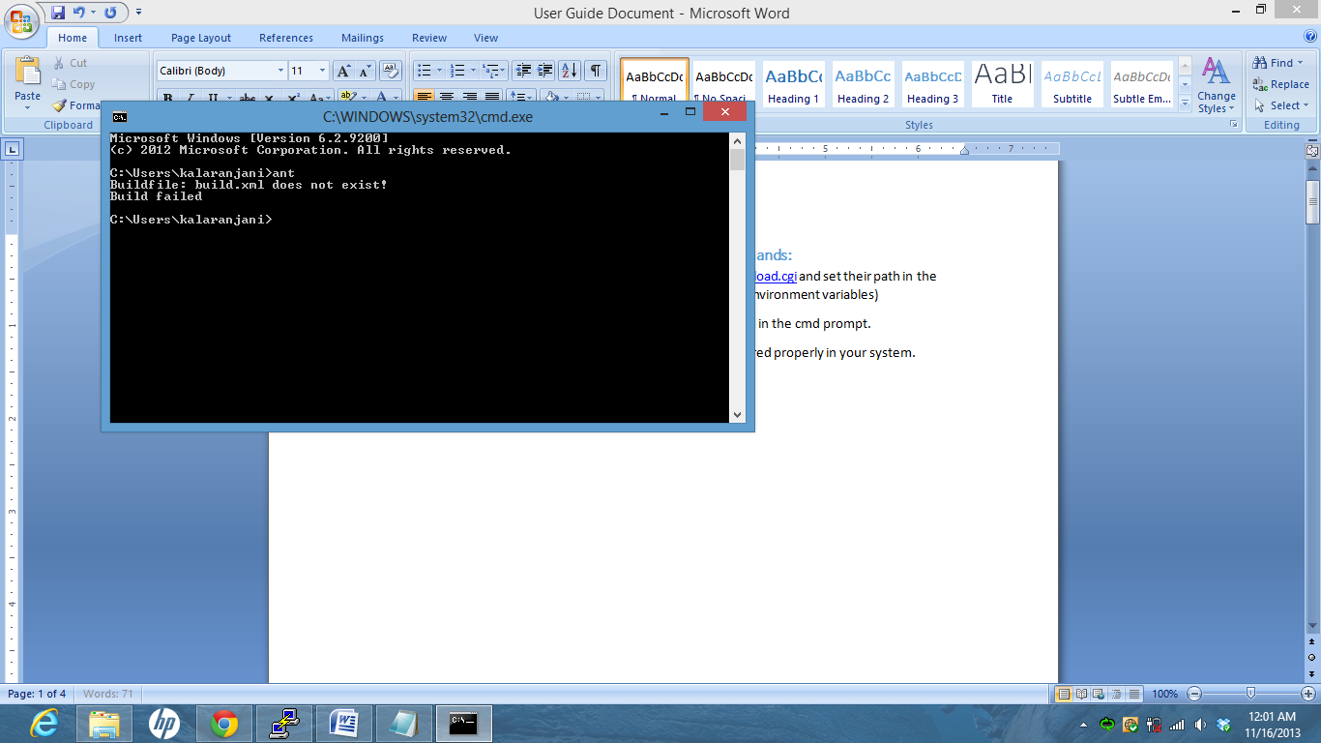

## Step 2 : Verify Java JDK is installed and JAVA_HOME is also included in the path.

JAVA_HOME is also included in the environment variable named path.Follow the steps used in Step 1. (eg.JAVA_HOME='C:\Program Files\Java\jdk1.7.0_40\jre')

## Step 3 : Place the application project and Test project in the Tools folder inside android-sdk

(eg. C:\Kala\Android-Essential-Software-Packages\adt-bundle-windows-x86\adt-bundle-windows-x86\sdk\tools)

## Step 4: Set ant to your application project

android update project -p <<android-app>>

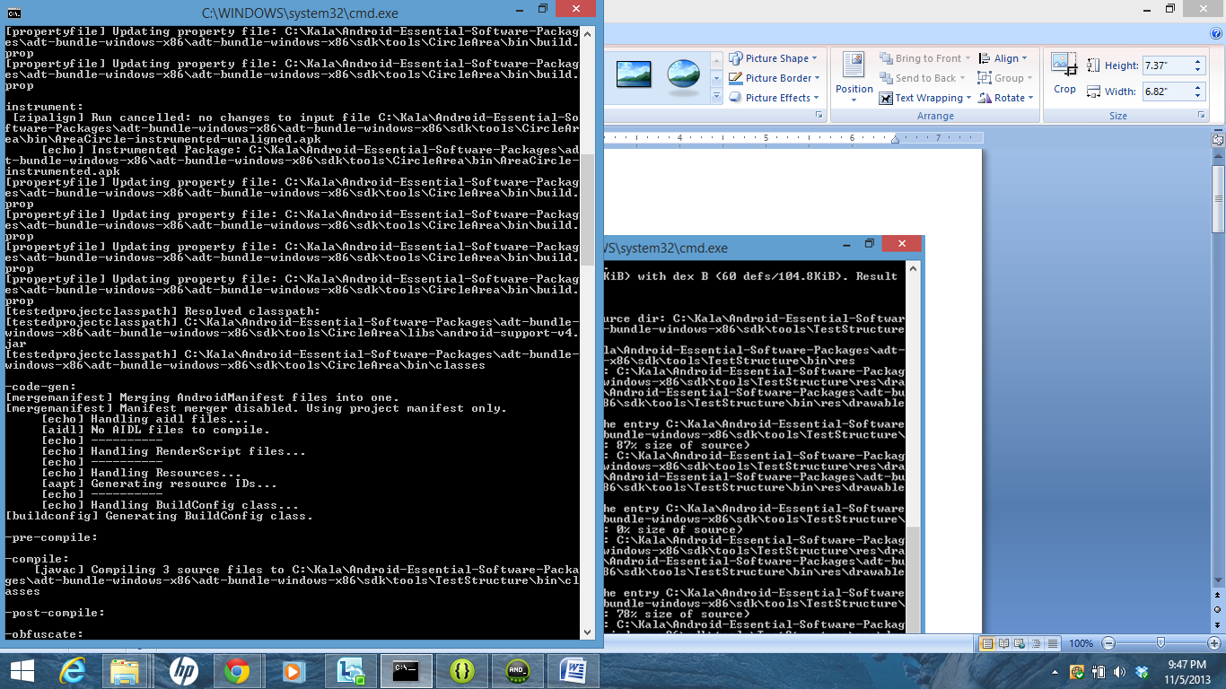

**Step 5:Set ant to your test project**

android update test-project -m ../<<android-app>> -p <<android-test>>

**Step 6 :Build the application project**

ant clean debug

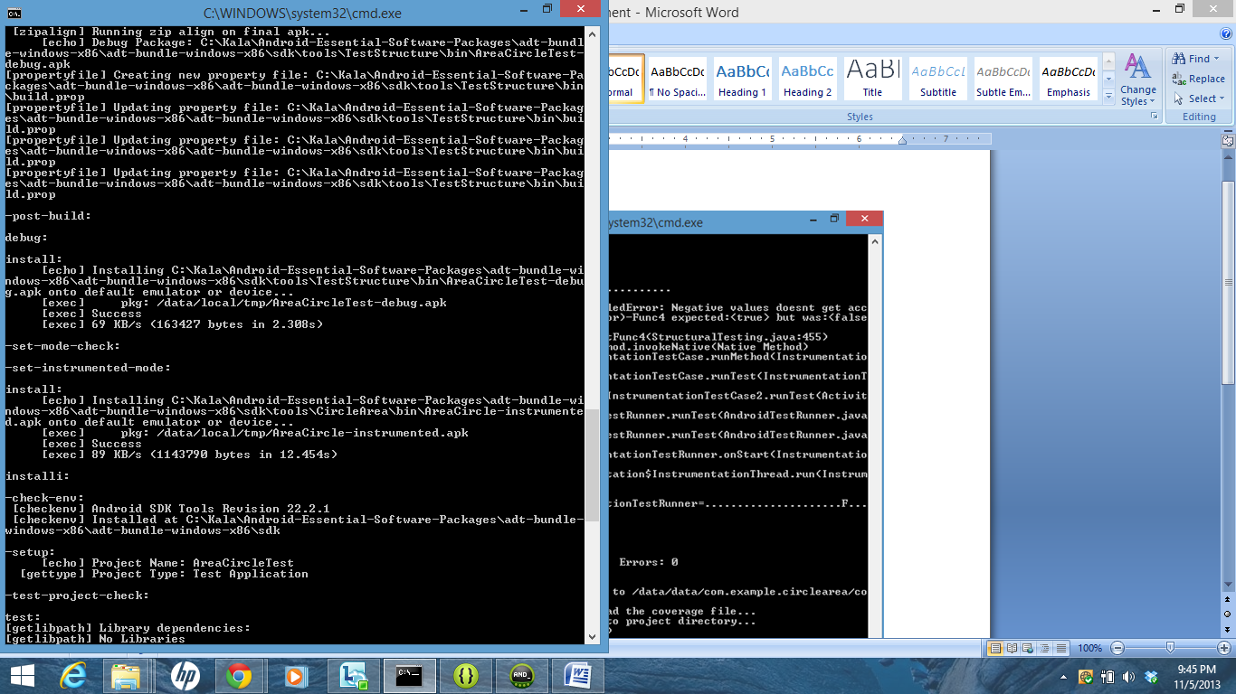

**Step 7 : Open the virtual Emulator**

Make sure you start the virtual emulator so that this gives a way to execute your test cases.

**Step 8:Add robotium jar files**

Add your robotium jar files to the libs folder in your test project to avoid 'Solo' Error.

(eg: C:\Kala\Android-Essential-Software-Packages\adt-bundle-windows-x86\adt-bundle-windows-x86\sdk\tools\TestStructure\libs)

**Step 9: Execute your test cases through ant window**

ant clean emma debug install test

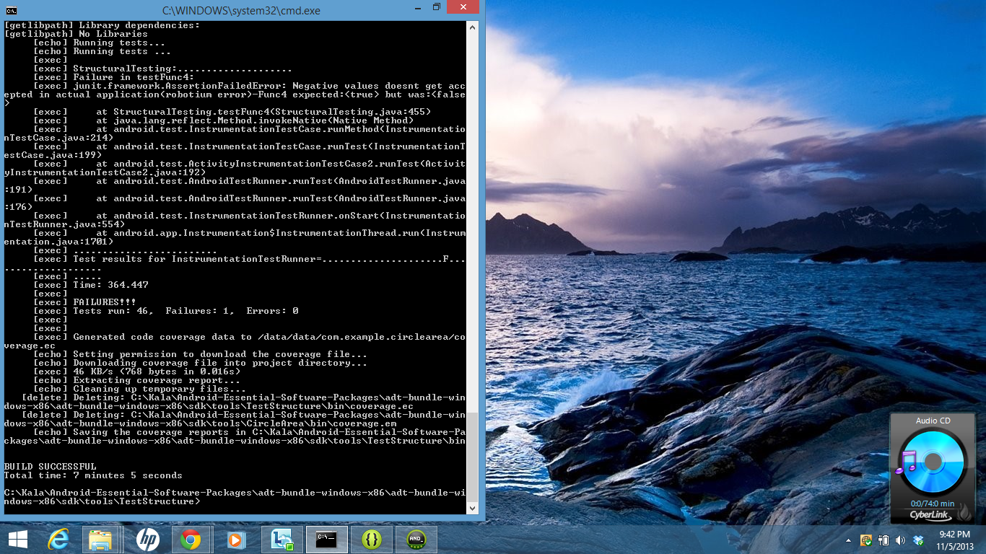

**Step 10: Check the code coverage report**

Code coverage report will be generated in the bin folder of your Test Project.

(eg: C:\Kala\Android-Essential-Software-Packages\adt-bundle-windows-x86\adt-bundle-windows-x86\sdk\tools\TestStructure\bin)

## References:

https://wiki.jenkins-ci.org/display/JENKINS/Building+an+Android+app+and+test+project